# Result Task 01: Test Star Data

* + SCD2 Dimension tests – Repeatable, Content

**DIM_LOCATIONS_SCD - SCD2 Dimension**

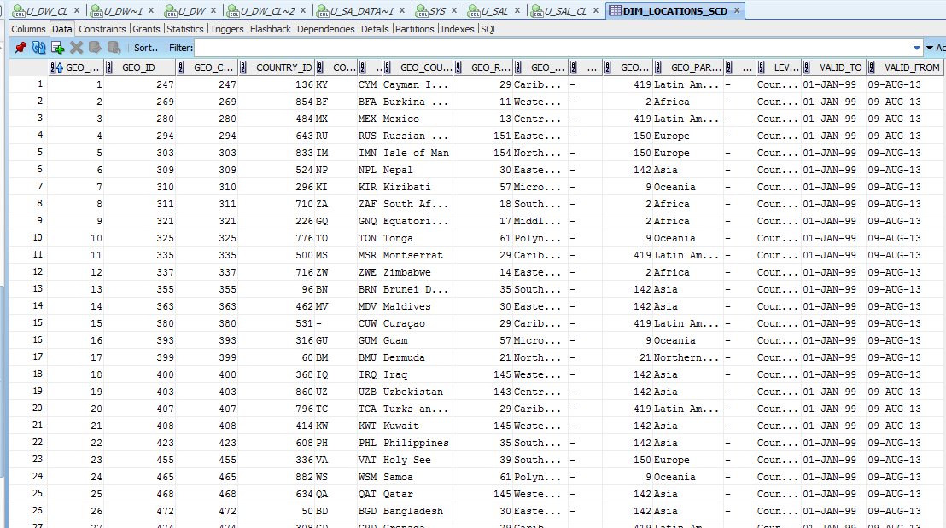

Table is not changed after multiple startup procedure

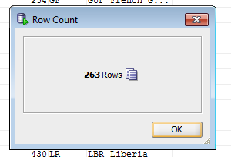

BEGIN

pkg_load_dim_location.load_location;

END;

BEGIN

pkg_load_dim_location.load_location;

END;

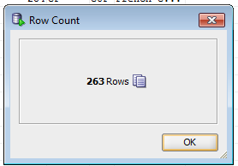

After updating the data in the source table and restart the package data is changed at star-level.

History of changes data is stored in the table:

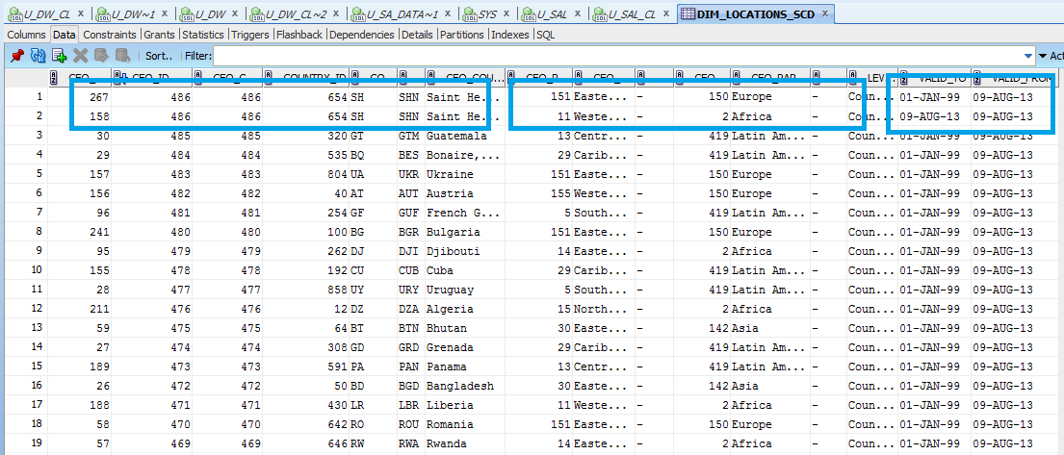

**DIM_CURRENCY_SCD - SCD2 Dimension**

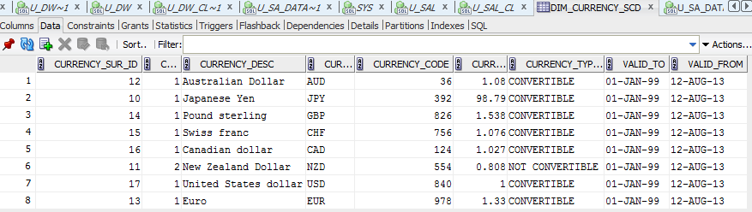

Table is not changed after multiple startup procedure

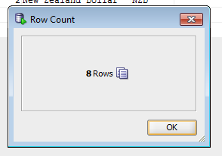

BEGIN

pkg_load_dim_currency_sal.load_currency;

END;

BEGIN

pkg_load_dim_currency_sal.load_currency;

END;

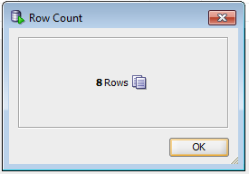

After updating the data in the source table and restart the package data is changed at star-level.

History of changes data is stored in the table:

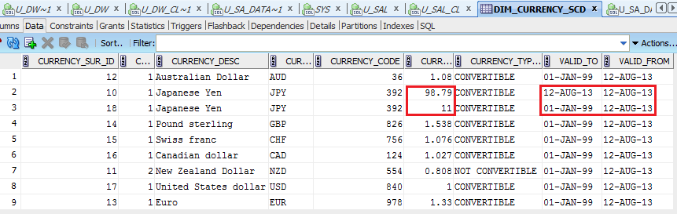

* + Common Dimension

DIM_CUSTOMERS

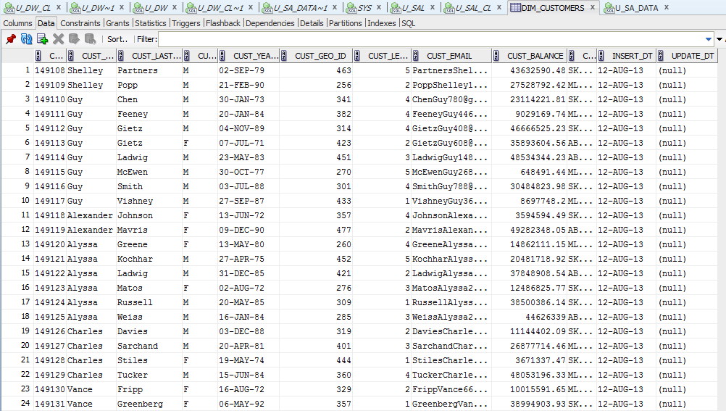

DIM_OPERATIONS

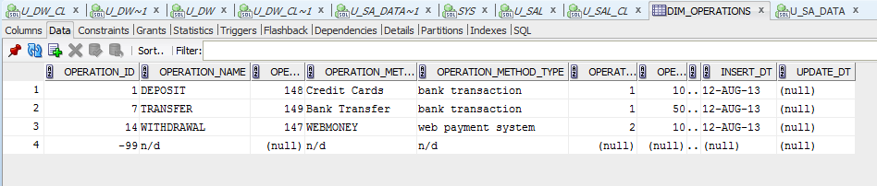

DIM_TARIFFS

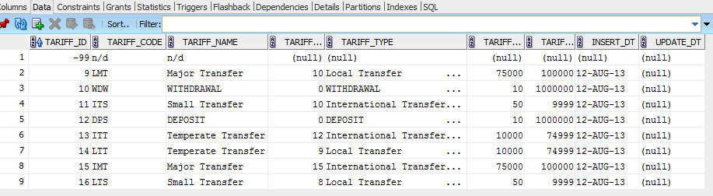

DIM_TIMES_DAILY

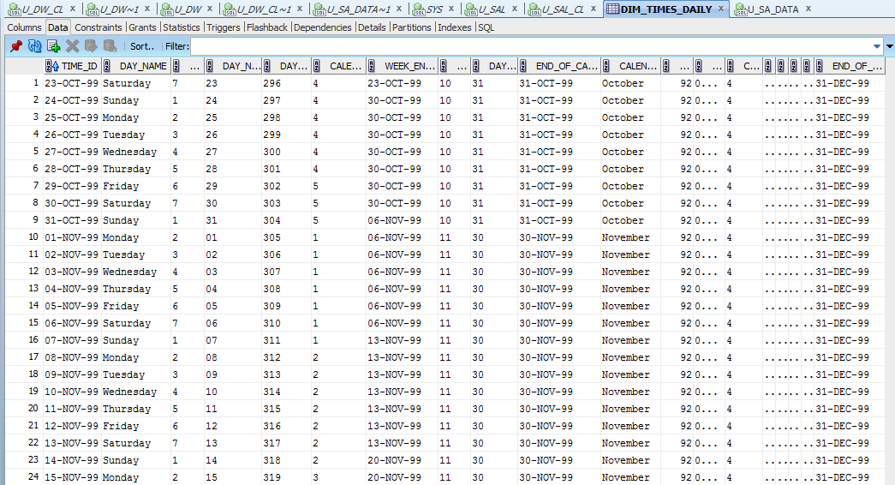

DIM_GEN_PERIODS

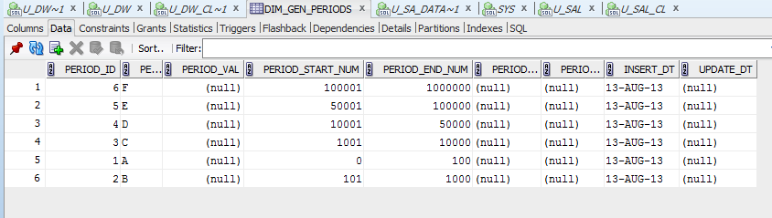

* + Fact Table

FCT_TRANSACTION_DAILY

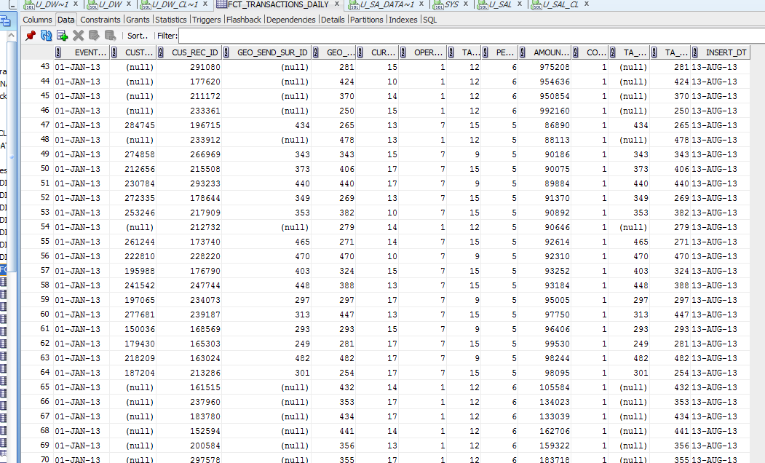

* + Star Solution Scheme (Physical Objects)

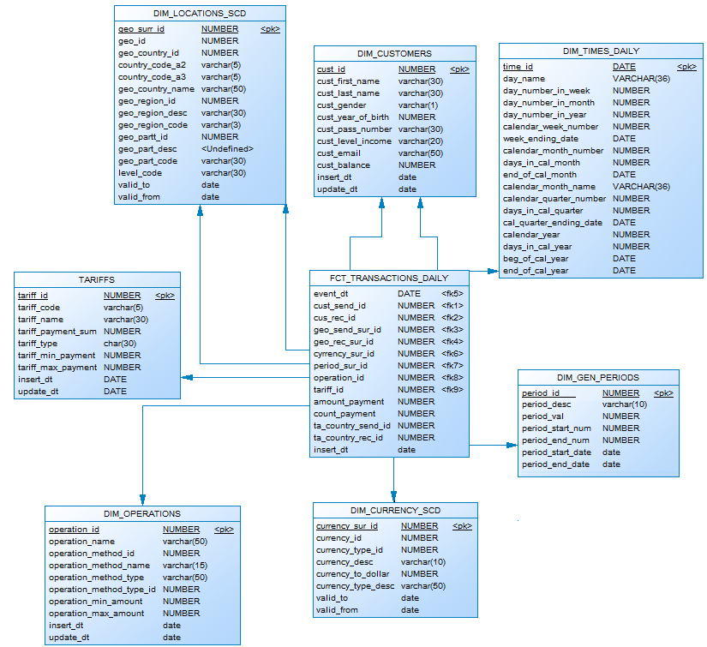

## Task 03: Compare Report Layout Performance

**The Main Task** is to create summarize table with comparison Performance of next Report Layout:

- Advancing Grouping (GROUP BY GROUPING SETs – LabWork 02)

- Model Clause (LabWork 05)

- Star Schema (LabWork 11)

**Task Results:**

|  |  |  |  |
| --- | --- | --- | --- |
| № | Source Type | Explain Plan - Statistics | Time, msecs. |
| 1 | Advancing Grouping |  | 351 msecs |
| 2 | Model Clause |  | 649 msecs |
| 3 | Star Schema |  | 53 msecs |